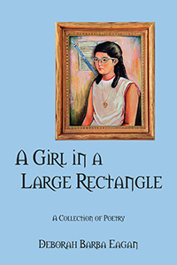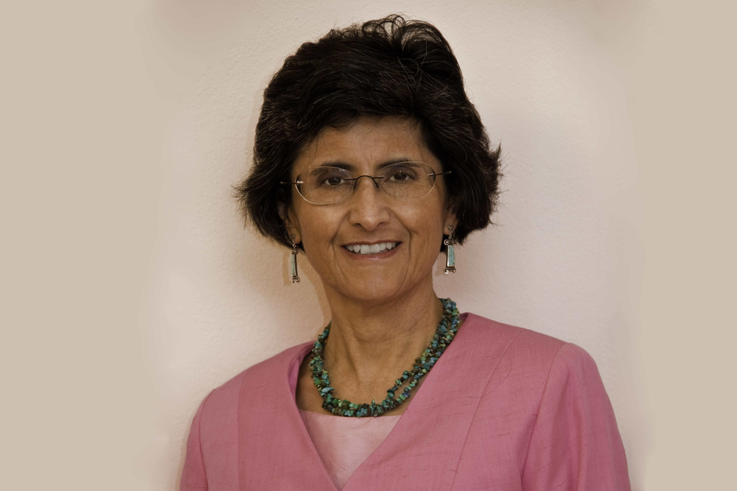

A Girl in a Large Rectangle: A Collection of Poetry
NMSPS Poet Deborah Barba Eagan

This recently published chapbook is available on Amazon.com for $9.95 plus shipping and handling. Poets and readers are welcome to make inquiries to the author at deborah.eagan@gmail.com or by phone at 505.889.3774 for autographed copies for $9.95 + $.75 tax.

A Girl in a Large Rectangle is the debut poetry collection of Deborah Barba Eagan, the 2006 Albuquerque Tricentennial Poet. In her poetry she shares her passion for family, music, nature, travel and ultimately for life. The cover image of this chapbook is a photo of an oil portrait of the author when she was 12 years old it when it was painted and framed in a large rectangle of gilded wood. Consequently, “A Girl in the Large Rectangle” is both the book title and the title of one the poems where the author recalls gazing at it and pondering her future. Now, much of that future has come and gone and in these poems she looks back on moments in her life.

Deborah Barba Eagan of Albuquerque, New Mexico has read her poems at several past events in Albuquerque and in Las Cruces. She belongs to SouthWest Writers, the New Mexico State Poetry Society and the Albuquerque TGIF Poetry Group. In April 2004, for National Poetry Month, she was featured on the children’s radio program, Read Albuquerque. Several of her poems have been published in the Albuquerque broadside, the Rag. As the Albuquerque Tricentennial Poet in 2006 her poem, “Come See Albuquerque,” was published on the Tricentennial website.

