 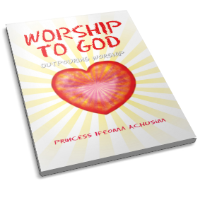

Exalting God through the power of the written word, author Princess Ifeoma Achusim shares twenty short yet meaningful poems that send messages of worship and glory. **WORSHIP TO GOD** talks of the effect of the Word of God in the life of a believer, the fruits of the Spirit, communication with God, and more. After each poem, the author provides a commentary, explaining the poem’s significance, including the time, place, and her inspiration for writing it.

Paired with moving illustrations that uplift the heart, enlighten the mind, and refresh the soul, **WORSHIP TO GOD** is also a loving invitation to give thanks to the Almighty through prayers and exaltation.

Available through local bookstore’s order desk or at these online bookstores: Amazon.com, Barnesandnobles.com, Xlibris.com, outpouring worship.com or by phone at 1-888-795-4274 ext.7879.